Aliaa El-Hosainy
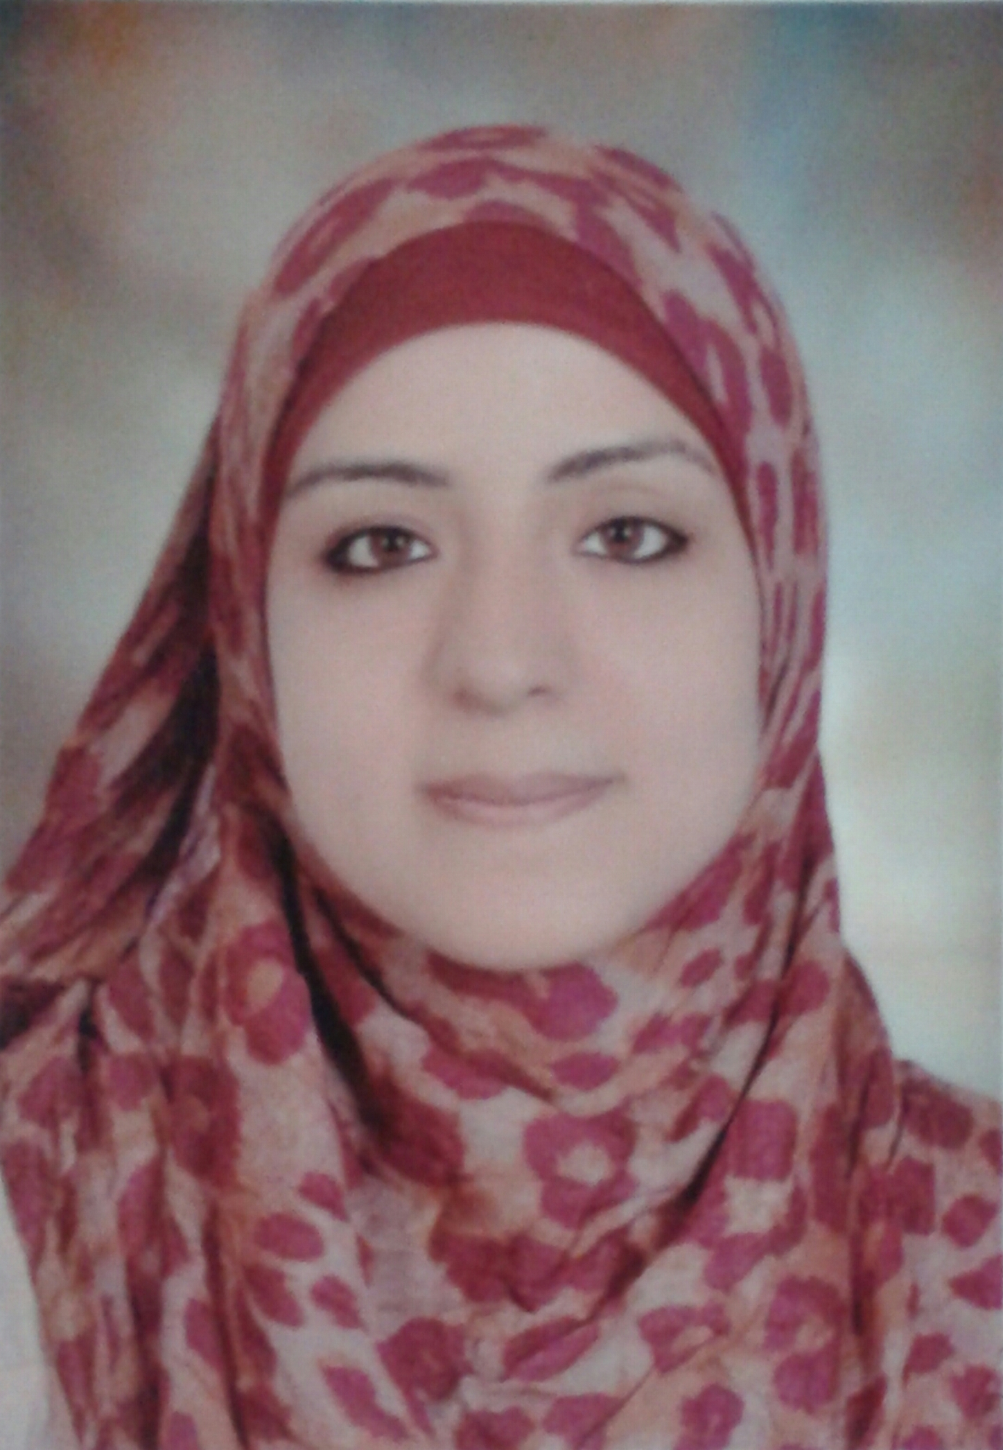

Personal data

NAME | : | Aliaa El-Hosainy Mohammad Mahmoud
TITLE | : | Demonstrator of pathology, Assiut university
Gender | : | Female
DATE OF BIRTH | : | 4, June, 1988
NATIONALITY | : | Egyptian
MARITAL STATE | : | Married
AFFILIATION | : | Pathology department, faculty of medicine, Assiut university, Egypt.
CORRESPONDENCE ADDRESS | : | 6th Al-roodah st, Assiut, Egypt
CURRENT HOME ADDRESS | : | 6th Al-roodah st, Assiut, Egypt
PHONE NO. | : | Mobile +201115353591
E-MAIL | : | aliaa.elhosainy88@yahoo.com  aliaa.elhosainy@aun.edu.eg

POSTS HELD

POSITION | FROM | TO | PLACE OF WORK
HOUSE OFFICER | 1/3/2012 | 28/2/2013 | Assiut university hospital(AUH)
DEMONSTRATOR | 2/3/2013 | Up till now | Pathology department, AUH

Qualifications
M.B.B.Ch , Excellent with honor , Faculty of Medicine , Assiut University , 2011

Research
- Illustrated research on different patterns of trauma arriving to emergency units at my university hospital.
- Field visits to different primary health care units in my country.

EXPERIENCES
- As a medical student:

- During internship:

- Research and experience

Languages
Arabic (mother tongue)
English

